***Reverse a Doubly Linked List***

Given a Doubly Linked List, the task is to reverse the given Doubly Linked List.

**Example:**

***Input:***

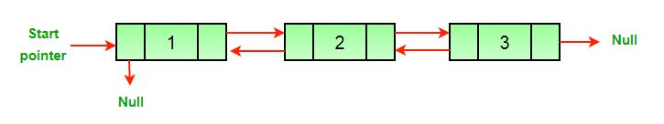

***Output:***

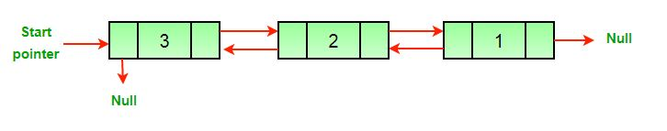

Follow the given steps to solve the problem using the above approach:

* Traverse the linked list using a pointer
* Swap the prev and next pointers for all nodes
* At last, change the head pointer of the doubly linked list

Below is the implementation of the above approach:

C++Java

// Java program to reverse a doubly linked list

class LinkedList {

static Node head;

static class Node {

int data;

Node next, prev;

Node(int d)

{

data = d;

next = prev = null;

}

}

/* Function to reverse a Doubly Linked List */

void reverse()

{

Node temp = null;

Node current = head;

/* swap next and prev for all nodes of

doubly linked list */

while (current != null) {

temp = current.prev;

current.prev = current.next;

current.next = temp;

current = current.prev;

}

/* Before changing head, check for the cases like

empty list and list with only one node */

if (temp != null) {

head = temp.prev;

}

}

/* UTILITY FUNCTIONS */

/* Function to insert a node at the beginning of the

* Doubly Linked List */

void push(int new_data)

{

/* allocate node */

Node new_node = new Node(new_data);

/* since we are adding at the beginning,

prev is always NULL */

new_node.prev = null;

/* link the old list of the new node */

new_node.next = head;

/* change prev of head node to new node */

if (head != null) {

head.prev = new_node;

}

/* move the head to point to the new node */

head = new_node;

}

/* Function to print nodes in a given doubly linked list

This function is same as printList() of singly linked

list */

void printList(Node node)

{

while (node != null) {

System.out.print(node.data + " ");

node = node.next;

}

}

// Driver's code

public static void main(String[] args)

{

LinkedList list = new LinkedList();

/* Let us create a sorted linked list to test the

functions Created linked list will be 10->8->4->2

*/

list.push(2);

list.push(4);

list.push(8);

list.push(10);

System.out.println("Original linked list ");

list.printList(head);

// Function call

list.reverse();

System.out.println("");

System.out.println("The reversed Linked List is ");

list.printList(head);

}

}

**Output**

Original Linked list

10 8 4 2

Reversed Linked list

2 4 8 10

**Time Complexity:**O(N), where N denotes the number of nodes in the doubly linked list.  
**Auxiliary Space:**O(1)